SMAI Project – Report

Fingerprint Recognition System

# Brief description of the project

Fingerprints are considered to be valid evidences in law courts all over and hence any breakthrough in fingerprint matching would be highly useful. There have been studies to develop an intelligent automatic fingerprint identification and verification system using feature extraction via image processing and classification via ANNs. We started off with an aim to be able to implement such a system using physical features from fingerprint images and classifying them using ANN. As this was turning out to be slightly problematic, after consultation with our mentor, we changed our approach and after minutiae extraction, we used an alignment-based elastic matching algorithm. Also, we intend to extend our project with efforts towards fingerprint-based gender classification.

**Methodology adopted**

Using the following sample fingerprint image, we demonstrate the various stages of the methodology adopted by us:

A description...

**Fingerprint Enhancement**

Fingerprint images may be degraded and corrupted with elements of noise due to many factors including variations in skin and impression conditions. For this, we use fingerprint enhancement techniques that is based on the convolution of the image with Gabor filters tuned to the local ridge orientation and ridge frequency. The main stages of this algorithm include:

**Segmentation**- It involves separating the foreground regions in the image from the background regions. The image is divided into blocks and the grey-scale variance is calculated for each block in the image. If the variance is less than the global threshold, then the block is assigned to be a background region; otherwise, it is assigned to be part of the foreground.

The sample fingerprint image after segmentation:

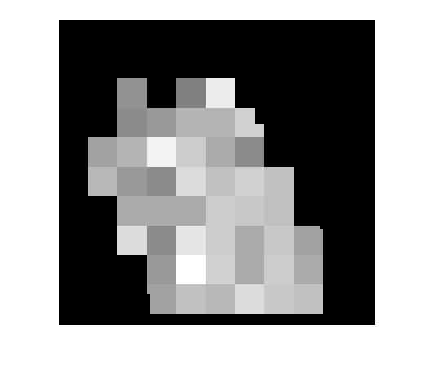

**Normalization**- This method is to standardise the intensity values in an image by adjusting the range of grey-level value.

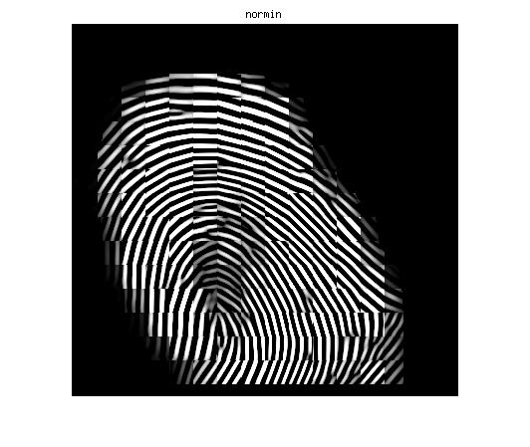

**Gabor filtering** - The following two procedures are used as parameters for construction of Gabor filters:

**Orientation estimation**- It defines the local orientation of the ridges contained in the fingerprint.

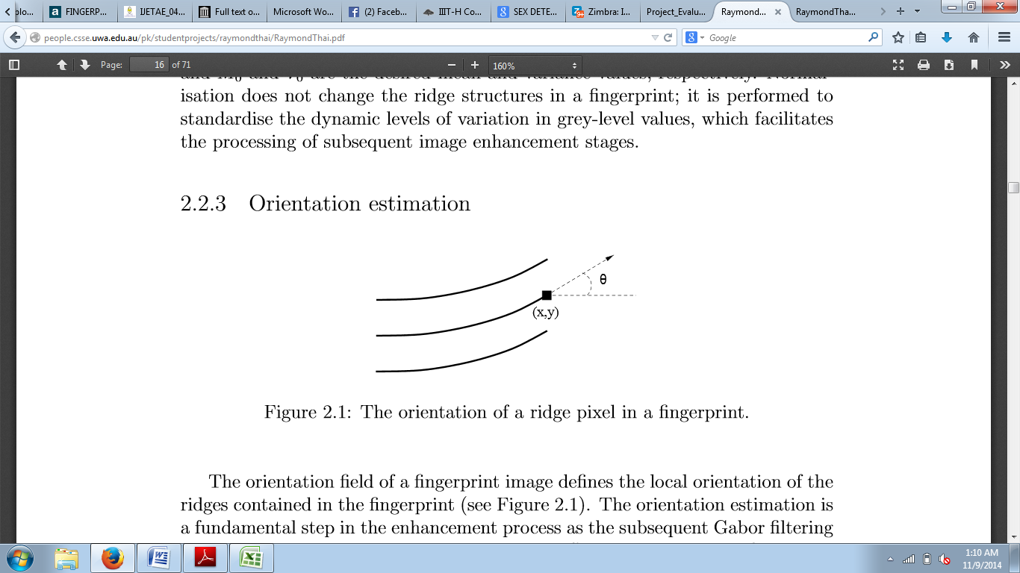

The sample fingerprint image with ridge orientations:

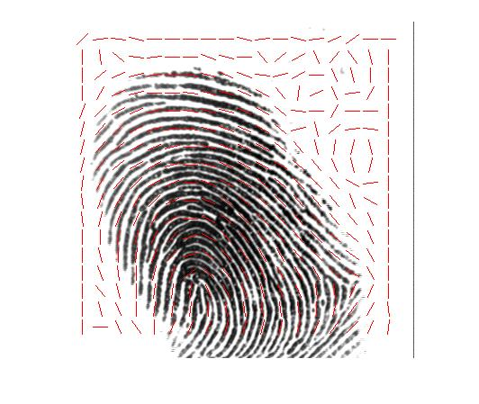

**Ridge frequency estimation** - The frequency image represents the local frequency of the ridges in a fingerprint.

A two-dimensional Gabor filter consists of a sinusoidal plane wave of a particular orientation and frequency. A properly tuned Gabor filter can be used to effectively preserve the ridge structures while reducing noise. The Gabor filter is applied to the fingerprint image by spatially convolving the image with the filter.

**Binarisation** - This is the process that converts a grey-level image into a binary image. This improves the contrast between the ridges and valleys in a fingerprint image, and consequently facilitates the extraction of minutiae.

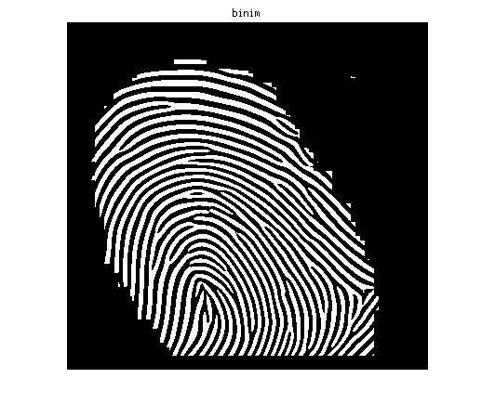

**Thinning** – This is a morphological operation that successively erodes away the foreground pixels until they are one pixel wide reserves the connectivity of the ridge structures while forming a skeletonised version of the binary image. This skeleton image is then used in the subsequent extraction of minutiae.

The enhanced version of our sample fingerprint image is:

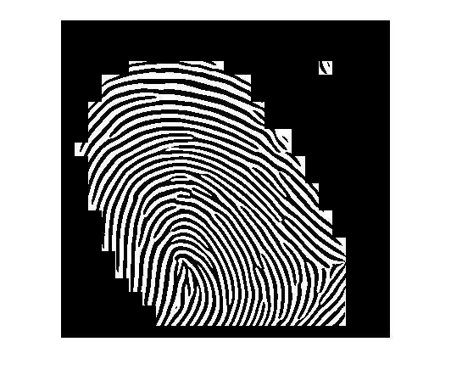

**Minutiae extraction:**

Minutiae extraction is done using the skeletonised form of the input image. For the sample fingerprint image, skeletonised image is:

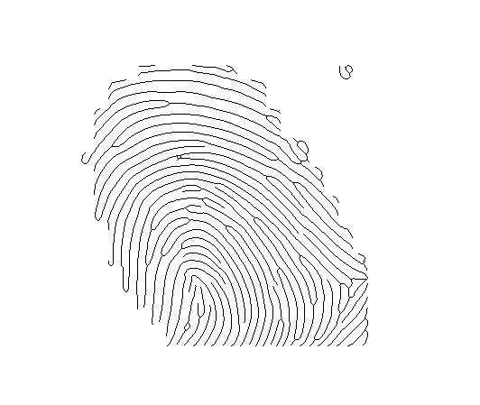

We have used the Crossing Number (CN) concept for minutiae extraction. This method uses the skeleton image where the ridge flow pattern is eight-connected. The local neighbourhood of each ridge pixel is scanned using a 3X3 window and CN value is computed, which is half the sum of the differences between pairs of adjacent pixels in the eight-neighbourhood. The ridge pixel can then be classified as a ridge ending, bifurcation or non-minutiae point as follows:

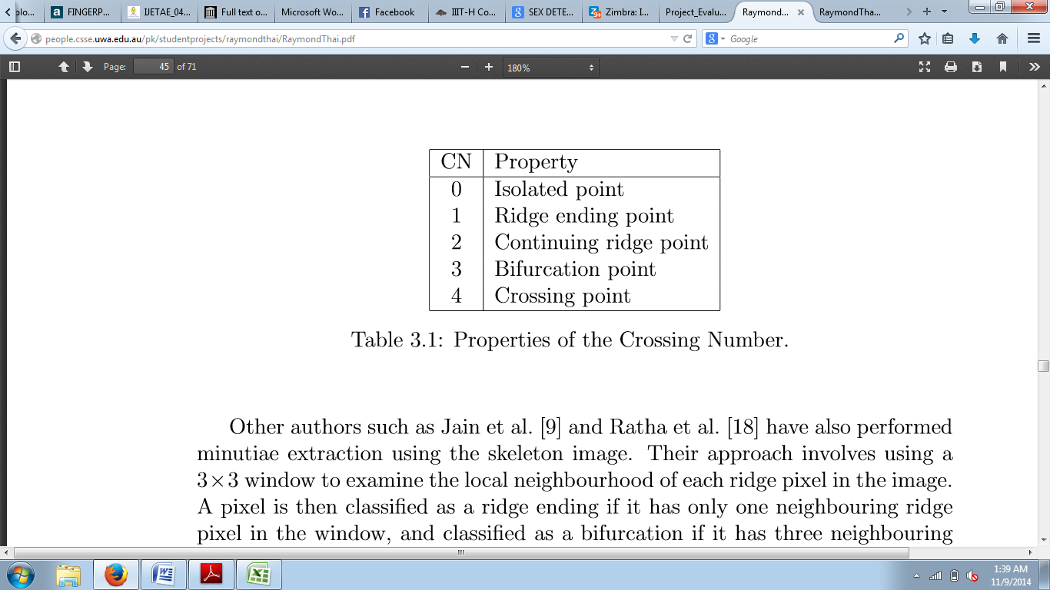

The following is the image obtained after extraction of minutiae:

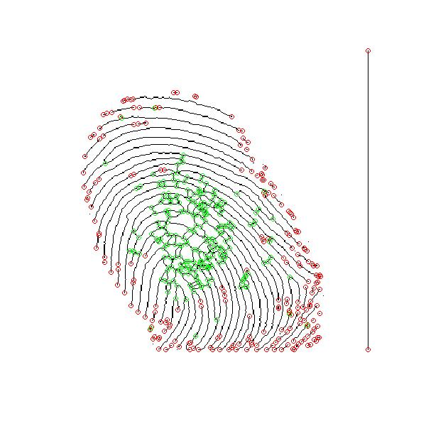

**Fingerprint image post-processing**:

It so happens that many a time false minutiae get identified that need to be removed.

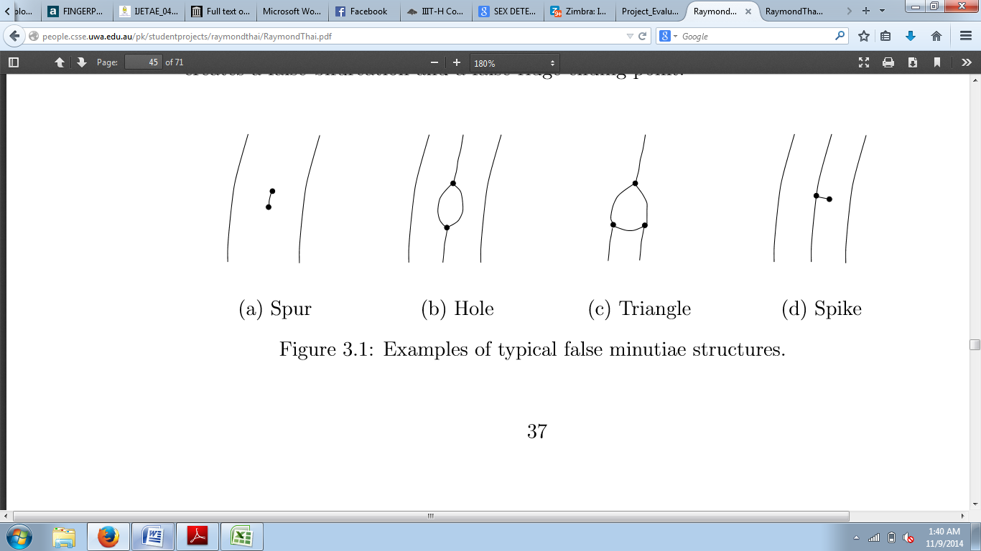

For getting rid of extra minutiae, we only consider those minutiae that lie within our region of interest, and also, we have set a minimum distance threshold that needs to be there between two valid minutiae. The sample fingerprint image after identifying our region of interest:

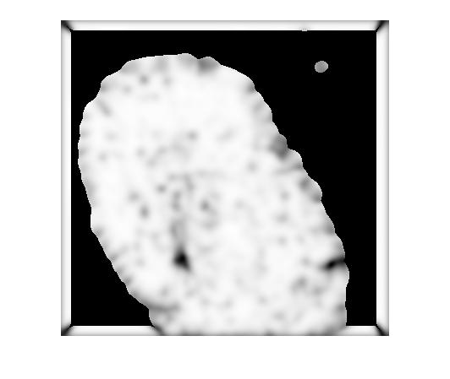

The sample fingerprint after suppressing the false minutiae:

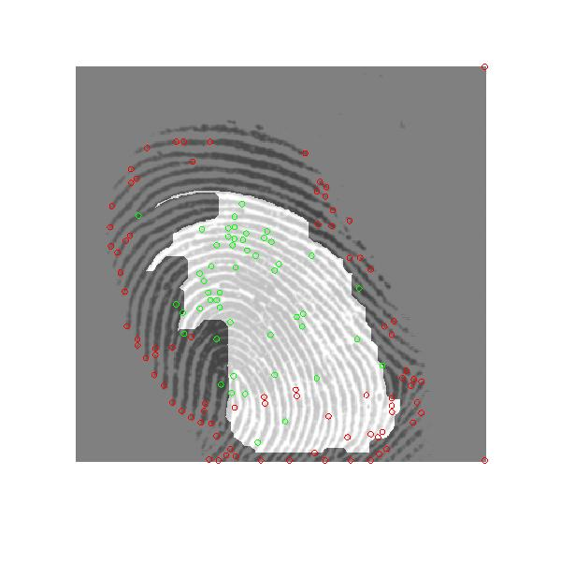

The images with the initial query image and final enhanced image are:

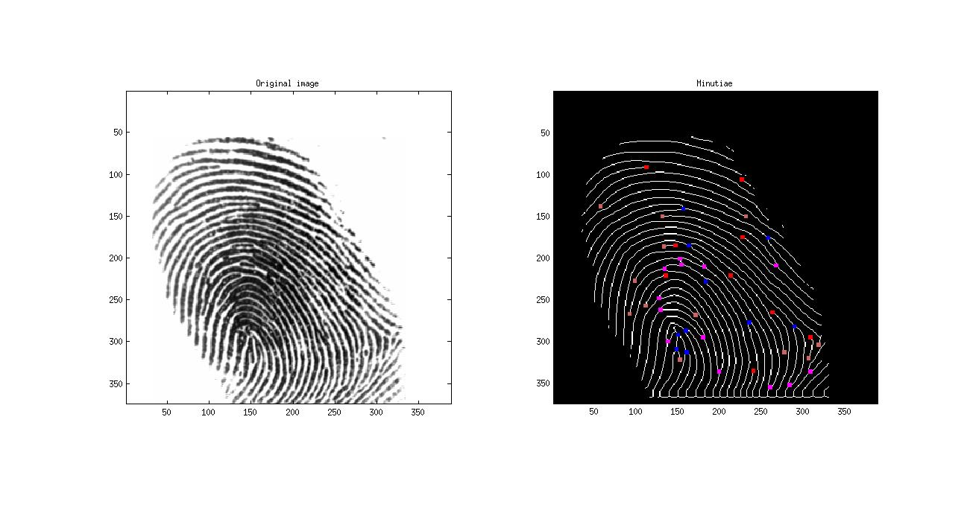

**Minutiae Matching:**

After extracting the minutiae and clearly defining the features, the feature vector of the query image and the image from the database are compared. It may be possible that the fingerprint images may not be oriented in the same way, so we start with aligning the images by applying transformation which is implemented using rotation matrix. The older feature vector is mapped to the thus obtained feature vector which is used for further processes. The threshold for the Euclidean distance between two minutiae is defined as 15 and that for the difference in their orientation angle is defined as 14, if this is satisfied, only then this particular minutiae is taken into account for calculating the similarity index. The match score is defined as:

Similarity index = √(n2/(Count1*Count2))

Where, n=total number of matching minutiae that satisfy our threshold conditions, Count1 = total number of minutiae in query image, Count2 = total number of minutiae in the image from the database.

To determine all the possible matches for the query image, we need to decide the threshold, which is done using the following analysis:

(i) FMR(False Match Rate)-When the algorithm classifies as genuine an actual impostor comparison

(ii) FNMR(False non-Match Rate)-When the algorithm classifies as impostor an actual genuine comparison

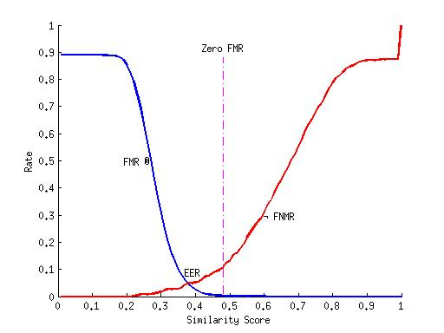  
**Features used**

The features that we are taking into consideration are:

(i) x coordinate of minutiae

(ii) y coordinate of minutiae

(iii) Crossing number as calculated for the minutiae

(iv) Orientation of minutiae in radians

**Papers read**

1) Fingerprint image enhancement : Algorithm and performance evaluation, Hong, L., Wan, Y., and Jain, A. K.(IEEE Transactions on Pattern Analysis and Machine Intelligence 1998)

2) An Intelligent Automatic Fingerprint Recognition System Design, Necla ÖZKAYA, Şeref SAĞIROĞLU, Arif WANI(International Conference on Machine Learning and Applications, 2006)

3) Fingerprint Recognition Using Artificial Neural Network, Tripti Rani Borah, Kandarpa Kumar Sarma & Pran Hari Talukdar(International Journal of Electronics Signals and Systems, 2013)

4) A Study on Various Methods of Gender Identification Based on Fingerprints, Ms. Ritu Kaur, Mrs. Susmita Ghosh Mazumdar, Mr. Devanand Bhonsle(International Journal of Emerging Technology and Advanced Engineering, 2012)

5) Sex Determination From Fingerprint, R. A. Tadross, A. M. Badawi, M. R. Mahfouz, R. L. Jantz, C. M. Blair(Cairo International Biomedical Engineering Conference, 2006)

6) Fingerprint Based Gender Identification Using Frequency Domain Analysis, Ritu Kaur and Susmita Ghosh Mazumdar(International Journal of Advances in Engineering & Technology, 2012)

7) Fingerprint Image Enhancement and Minutiae Extraction, Raymond Thai(School of Computer Science and Software Engineering, The University of Western Australia, 2003)